Procedure to Simulate Large-Scale PMUT Arrays Combining Equivalent-Circuit Models with GPU Acceleration
Sandgasse 34, 8010 Graz
SAL Building * - RoomNr.

Index
1. Purpose AND SCOPE 3
Definitions and Abbreviations 3
Validity 5
2. Access Authorisation 5
3. PROCEDURE 5
3.1 PM300 Piezometer Setup Parameters 5
3.2 Piezoelectric thin film wafer preparation 5
3.3 Singulation of piezoelectric layer sample to characterize 6
3.4 Singulated DUT sample preparation 6
3.5 Metallization for contacting sample and piezometer 8
3.6 d33 characterization using PM300 PiezoMeter 9
4. Equipment and Workplaces 9
5. Risk Assessment 10
6. Emergencies and Accidents 10
7. RECORDS AND DOCUMENTATION SAFEKEEPING 10
8. Responsible Persons 10
9. Version 11

Purpose AND SCOPE
The purpose of this document is to generate a procedure for users seeking to characterize the piezoelectric charge constant d33 of a thin-film piezoelectric material on carrying substrate by means of a PiezoMeter PM300 setup (Fig. 1). This SOP deals with samples taken from wafers with deposited or transferred blanket piezoelectric thin films.
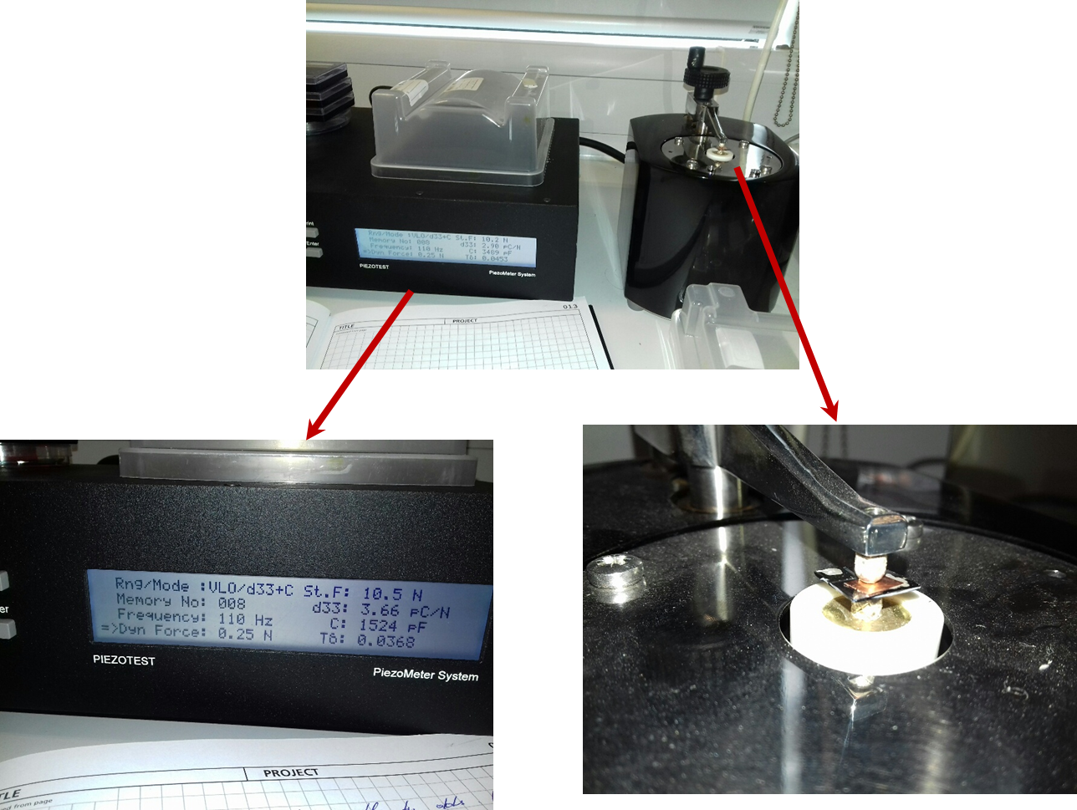
Fig. 1. PiezoMeter (PM300) test setup for measuring d33 coefficient.

Definitions and Abbreviations
Piezoelectric material: Any material that can generate internal electric charge from applied mechanical force. Piezoelectric material can be in bulk or thin film form. Bulk materials are usually 500 micrometers thick and do not require handle (or supporting) substrate while thin-film piezoelectric materials are much thinner up to around 4m, typically deposited on a supporting substrate for handling and post processing purposes.

Thin-film material: A thin-film piezoelectric material is usually up to around 4 m thick and is typically deposited on a supporting substrate for handling and post processing. Thin-film piezoelectric materials have lower piezoelectric response than bulk materials. Typical values of the d33 coefficient of a thin-film material are in the range of 1 – 30 pC/N, whereas in case of bulk materials the typical d33 coefficient is in the range of 10’s to 100’s pC/N.

Piezometer: Piezometer is a tool dedicated for testing piezoelectric response of materials. In SAL, the tool model is PM300 from PiezoTest.

How system works: The system works by clamping the sample and subjecting it to a low frequency mechanical force. Processing of the electrical signals from the sample, and comparison with a built-in reference, enables the system to give a direct reading of d33 – one of the most important parameters in evaluating the material. This is a material coefficient representing charge per unit force in the direction of polarization. The method of operation of this type of d33 meter is often known as the "quasi-static" or "Berlincourt" method. A key principle is that the test frequency is lower than any likely system or sample resonances, yet high enough to make a conclusive measurement within a few seconds.

Coordinate system and forces affecting a piezoelectric element definition: The direction of positive polarization usually coincides with the Z-axis of a rectangular system of X, Y, and Z axes (Fig. 2). Directions X, Y, and Z are represented by subscripts 1, 2, and 3, respectively, and shear directions about these axes are represented by subscripts 4, 5, and 6, respectively.

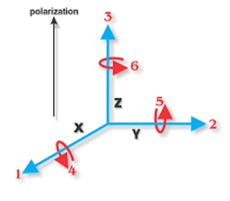
Fig. 2. Coordinate system and forces affecting a piezoelectric element

Piezoelectric charge constant dXY: Polarization generated per unit of mechanical stress (T) applied to a piezoelectric material (units: C/N), or, alternatively, is the mechanical strain (S) experienced by a piezoelectric material per unit of electric field applied (units: m/V). The first subscript X to d indicates the direction of polarization generated in the material when the electric field, E, is zero or, alternatively, is the direction of the applied field strength. The second subscript Y is the direction of the applied stress or the induced strain, respectively.

d33: Piezoelectric charge constant in direction “33”, induced polarization in direction 3 (parallel to direction in which piezoelectric element is polarized) per unit stress applied in direction 3 (units: C/N), or, alternatively, induced strain in direction 3 per unit electric field applied in direction 3 (units: m/V).

Validity
The instructions of the XXXX regarding laboratory operation, use of equipment and terms of safety must be obeyed to the best of your knowledge and belief.

Access Authorisation
To be completed
Must be defined

PROCEDURE

3.1 PM300 Piezometer Setup Parameters
• Test Frequency (AC Force): Calibrate the system at 110 Hz. Other frequencies may be used to tune away from sample resonances, which may change with sample dimensions. Range of frequency that can be used is 30Hz – 300Hz.
• Dynamic Force Amplitude: Testing can be performed at and oscillatory force, variable by user setting between 0.05 to 0.50 N. Typically amplitude of 0.25 N is used.
• Static Force Amplitude: Static force of approximately 10N should be used to grip the sample
• d33 ranges: appropriate measurement range have to be chosen according to sample d33 properties; for AlN and ScAlN samples a Very Low Range and Low Range are most appropriate.
• Very High Range: 100 to 10,000 pC/N
• High Range: 10 to 1000 pC/N
• Low Range: 1 to 100 pC/N
• Very Low Range: 0 to 10 pC/N
See documents “PM300 Operation Manual” and “PM300 Specifications Sheet” for more details on tool operation ranges.

3.2 Piezoelectric thin film wafer preparation
A wafer with piezoelectric thin film material must comply with following requirements in order to being suitable for characterization using the PM300 piezometer:
• To measure the d33 coefficient the piezoelectric layer must be metallized from both sides
• The bottom metal must be connected to the bottom surface of the substrate. This is a requirement by the operation principle of the PM300 piezometer.
• Note that there could also be other layers below the bottom metal and this should not disturb the measurements.
Fig. 3 shows an example cross-section of the basic stack of layers required for characterization using the PM300 PiezoMeter, including the piezoelectric layer.
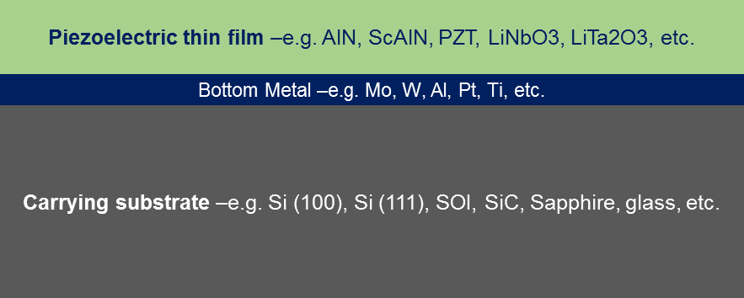
Fig. 3. A cross-section of the sample with a thin-film piezoelectric layer to be tested.
Examples of the stack layers, including the piezoelectric layer:
• Piezoelectric layer: AlN, ScAlN, deposited PZT, LiTa2O3, LiNbOe –typ. thickness 0.5-4.0 μm;
• Bottom metal: Mo, W, Al, Pt, Ti –typ. thickness 0.1-2.0 μm;
• Carrying substrate wafer: Si (100), Si (111), SOI, SiC, Sapphire, glass, etc. –typ. thickness 500-900 μm.
• Full wafer or wafer pieces.

3.3 Singulation of piezoelectric layer sample to characterize
This section refers to taking small pieces out of the carrying substrate, and use them individually as device under test (DUT) within the PM300 setup. There are two cases considered when singulating the DUT:
1. Dicing of full wafer: Dice the DUT out the wafer into pieces of approximately 1.5 cm by 1.5 cm, using saw dicing, for example. To standardize the quality and safety of dicing, this task will be carried out by trained personnel at the respective packaging lab (C.2.06);
2. Cleaving of full wafer or wafer pieces: Cleave the DUT off the wafer into pieces of approximately 1.5 cm by 1.5 cm. To standardize the quality and safety of cleaving, this task will be carried out by trained personnel at the respective packaging lab (C.2.06);

3.4 Singulated DUT sample preparation
This preparation must be requested to be done in SAL’s III-V fab and by trained personnel from this fab, as it requires access to 25% TMAH.
• Step 1: Take one DUT sample and ensure the thin-film piezoelectric layer is entirely protected / covered by a layer of photoresist. Photoresist type and processing conditions: spin on S1813 resist @ 4000 rpm – this gives a thickness of about 1.2 m. In addition, the resist can further be protected with the kapton tape.
• Step 2: Immerse approximately one third of the sample size in the beaker with the 25%-TMAH to remove the AlN film from the immersed area (the rest of the sample cannot be immersed otherwise the photoresist will dissolve in the TMAH). Typically 5 minutes in 25% TMAH is sufficient to remove 0.5 m thick AlN film but other and thicker films may require different process.
• Step 3: Remove the sample from the beaker and rinse with DI water.
• Step 4: Inspect the sample to confirm that the piezo layer is fully removed from the area that was immersed in the TMAH and the bottom metal is accessible. Optical inspection is typically sufficient to confirm that no AlN layer is present at the etched areas.
• Step 5: Remove the kapton tape and strip the resist from the entire sample in R1165 resist stripper @ 90C for 5 minutes and then rinse the sample in DI water.

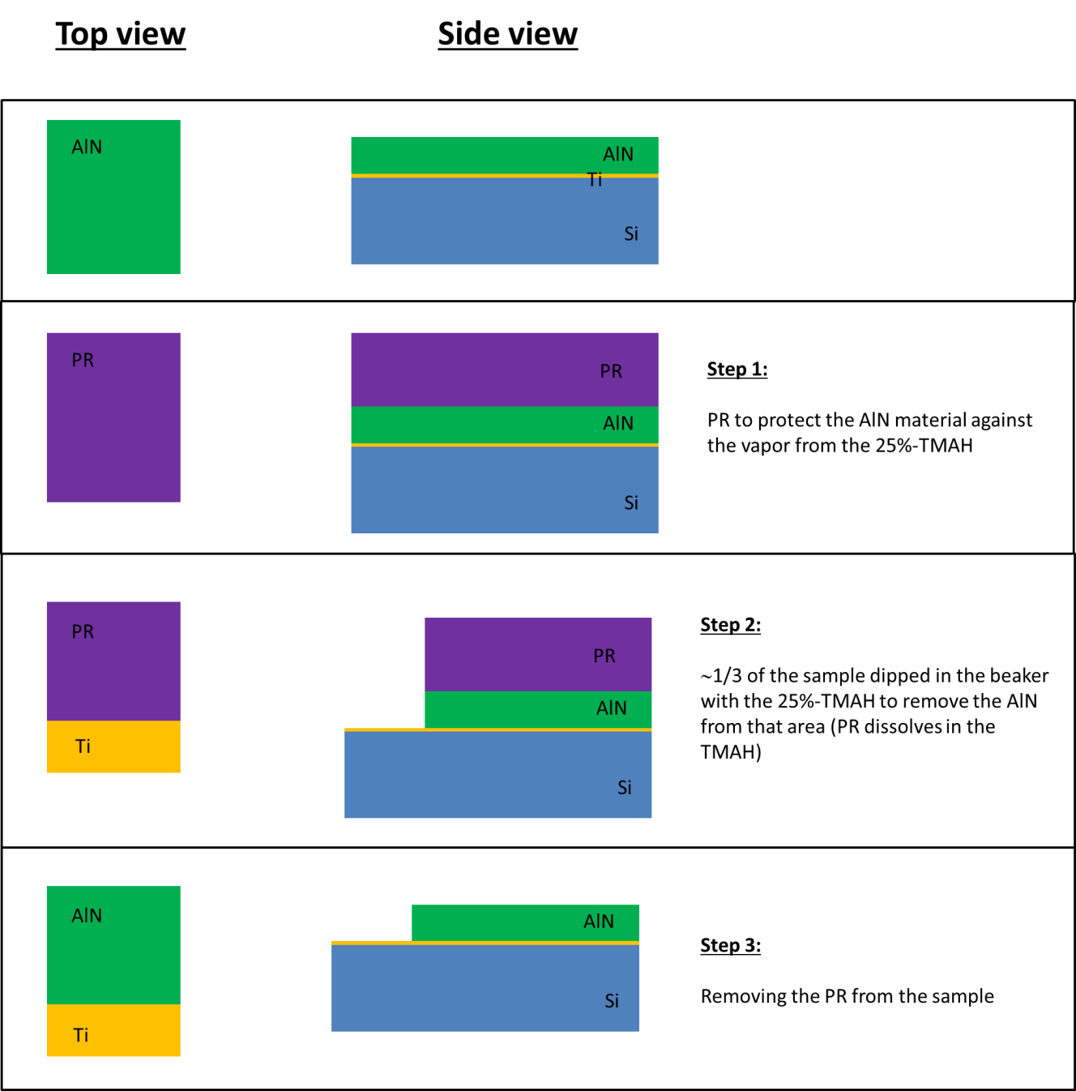
Fig. 4. Steps for DUT preparation.

3.5 Metallization for contacting sample and piezometer
This step of preparation will be carried out at SAL’s III-V fab, by trained personnel from this fab or by research staff upon basic training (not an activity critical for safety).
• Metal painting procedure: Apply silver conductive paint to the sample using a small brush to the top surface of the piezoelectric layer to create “top metallization”. Let the sample dry for about 20 minutes. Flip the sample over and paint the bottom surface of the substrate and the edge of the sample in order to create “bottom metallization and “edge metallization”, respectively. Note that the “edge metallization” provides electrical connection between the “bottom metallization” and the bottom metal electrode.
• Verification / inspection procedure: to verify the DUT is properly prepared, use a multimeter to check there is no short circuit between the top metallization and the bottom metal electrode (bottom metallization).
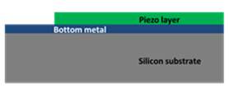
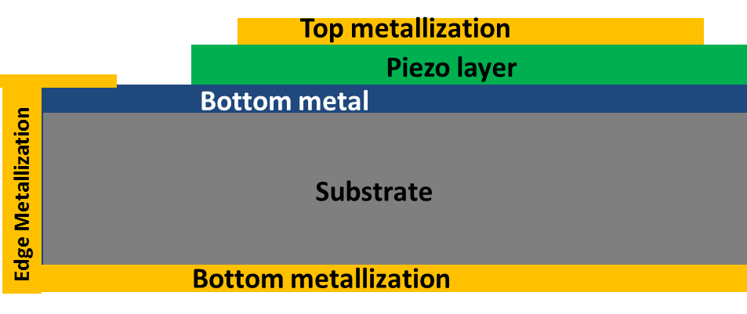
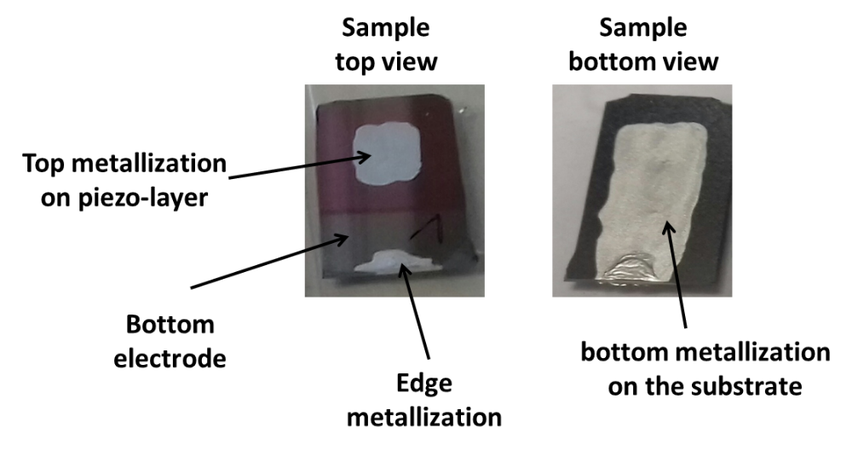
Fig. 5. DUT metallization.

3.6 d33 characterization using PM300 PiezoMeter
The table below describes the PM300 setup and measurement procedure steps:
Step | Instruction
1 | Supply mains A.C. power to the PM300.
2 | Switch on the PM300 and set desired parameters for:  - d33 range -e.g. for AlN: 0 to 10 pC/N and Sc-AlN: 1 to 100 pC/N  - Dynamic Force -e.g. for AlN: 0.25 N  - Test Frequency -e.g. for AlN: 110 Hz  - Static Force -e.g. for AlN: 10 N
3 | Clamp the sample on the measurement head according to user manual (note that the RED light indicate too much force while GREEN light indicates the force is correct). The static force should be at the level of approximately 10N.
4 | Read the d33 coefficient from the front panel of the PiezoMeter noting the measured value in the user lab book. Note that besides the d33 coefficient, the PM300 also shows the DUT capacitance and loss factor in the tool’s front panel. If this does not happen and the text message “Under” is displayed instead, it means the DUTs may be electrically shorted between the top and bottom metallization.

Extraction of d33 from the PM300 is typically a one-time measurement for a given sample. Therefore, it usually encompasses just single-value annotation or recording of the d33 value in a lab book. Optionally, there is option of connecting the PM300 to a PC to dump measurement data on the latter –this is an option barely needed. May the user refer to the PM300 operation manual for details.
Indirect extraction of d33 is one of the alternate methods used to benchmark the PM300-extracted d33 values–e.g. by means of electrical characterization of the frequency response of the resonant and antiresonant frequencies of a piezoelectric device. However, this SOP suggests the use of specific test/reference structures with known/expected d33 values, and that can be used in combination with the PM300 vendor’s calibration.

Equipment and Workplaces
Equipment layout (room plan)
Infrastructure
Equipment list (name, no. of person responsible) - if desired
To be completed
Equipment-specific hazards and safety measures (incl. pictograms)
Workplace-specific hazards and safety measures (incl. pictograms)
Media supply and disposal
Chemical hazards incl. gases

Risk Assessment
To be completed
A risk assessment according to MSR is to be carried out for self-produced machines or machine parts. (if required) *SPECIFIC RISKS OF RUNNING THIS PROCEDURE / TOOL

Emergencies and Accidents
Reporting obligations - Reporting channels
Fire protection - Special laboratory area
To be completed
First aid - Special laboratory area (chemical, thermal, mechanical)
Escape and rescue plan (general plan)
Emergency stop system (if available)
Emergency shut down system (if available)

RECORDS AND DOCUMENTATION SAFEKEEPING
The associated PM300 RA XXX-C&S-EqRA-274 is stored on QT9 and must be read, electronically signed off by all users. QT9 also stores a log of all users who have completed this risk assessment. PM300 user manual and specification document are also available on QT9.
To be completed

Responsible Persons
It is the responsibility of the HoRU and relevant PM to ensure the user has read and signed off the risk assessment for PM300 PiezoMeter Risk Assessment XXX-C&S-EqRA-274 and completed OACF C.1.11 SOP for Lab Induction in advance of using the PM300 PiezoMeter.
It is the responsibility of all users to read the user manual (located in the C.1.11 lab and on QT9) prior to using the PM300 Piezometer. It is the responsibility of all users to ensure strict compliance to this procedure.
It is the responsibility of the laboratory manager to ensure the user has read and signed off the C.1.11 OACF Lab RA Document XXX-C1.11-GRA-66.
To be completed
It is the responsibility of the C.1.11 OACF laboratory manager to update this document, if required.

Creator (in block capitals): First name + Surname

Lab Manager (in block capitals): First name + Surname
Mail Adress plus Telephone number

Direct Supervisor (in block capitals): First name + Surname
Mail Adress plus Telephone number

............................................................  Date, Signature Lab Manager | ................................................................  Date, Signature Supervisor

Version
Version | Date | Comment  To be completed | Prepared/amended by
V1.0 | XX.YY.ZZ | Creation | XXXXXXXX

